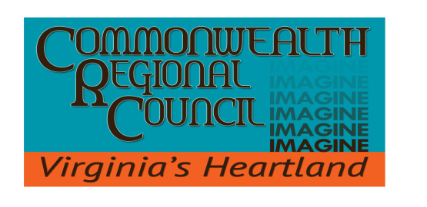
IN PARTNERSHIP WITH
The Counties of Amelia | Buckingham | Charlotte | Cumberland | Lunenburg |
Nottoway | Prince Edward

MEMORANDUM:
TO: CRC Council Members
FROM: Melody Foster
Executive Director
DATE: October 12, 2021
SUBJECT: Watershed Implementation Plan ( WIP) III (Contract IV) – Monthly Update

As you are aware, the Commonwealth Regional Council (CRC) has been assisting the Department of Environmental Quality (DEQ) in the implementation of Phase III of its Watershed Implementation Plan (WIP). The following activities have taken place since the last CRC Council meeting.

- Activities undertaken so far, include:

  - Finding and sending along grant opportunities to localities.
  - Updating CRC website.
  - Kristen Tillman participated in the virtual Riparian Consortium meeting.
  - CRC staff met virtually with VDH staff to discuss possible tracking of pump-outs of septic tank systems
  - CRC staff submitted CRC Regional Activities to DEQ for FY22 scope of work (SOW)
  - Kristen Tillman conducted the September Virtual CRC Local Government Guide to Chesapeake Bay Educational Series – Clean Water for the Economy for participants.
  - CRC staff participating in PDC Workgroup and DEQ virtual meetings.

Chesepeake Bay: Community Benefits of Clean and Healthy Waterways: Geese, ducks, deer, fish, and other wildlife rely on healthy habitats. In the United States, people on recreational fishing and hunting trips spent about $30 billion on gear, travel, and other purchases related to their craft in 2016.

COMMONWEALTH REGIONAL COUNCIL
One Mill Street, Suite 202 | P.O. Box P
Farmville, VA 23901 | 434.392.6104 PHONE
www.virginiasheartland.org

