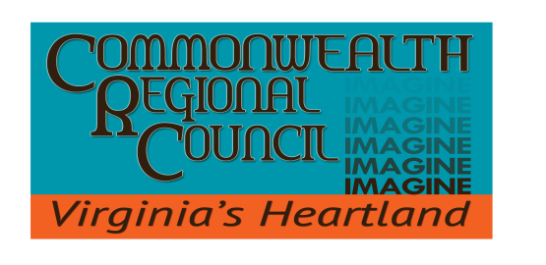
IN PARTNERSHIP WITH
The Counties of Amelia | Buckingham | Charlotte | Cumberland | Lunenburg |
Nottoway | Prince Edward

MEMORANDUM:
TO: CRC Council Members
FROM: Kristen Tillman
Regional Planner
DATE: March, 8 2022
SUBJECT: Watershed Implementation Plan (WIP) III (Contract IV) – Monthly Update

As you are aware, the Commonwealth Regional Council (CRC) has been assisting the Department of Environmental Quality (DEQ) in the implementation of Phase III of its Watershed Implementation Plan (WIP). The following activities have taken place since the last CRC Council meeting.

- Activities undertaken so far, include:

  - Finding and sending along grant opportunities to localities.
  - Updating CRC website.
  - Chesapeake Bay Webinar Series, Leveraging Hazard Mitigation for Water Quality Benefits
  - Met with Daniel Simms, the Environmental Justice Coordinator at DEQ, to discuss issues regarding environmental equity in our region.
  - CRC staff participating in PDC Workgroup and DEQ virtual meetings.

Chesapeake Bay: Reducing Transportation Sector Pollution – More than one third of carbon pollution comes from the transportation sector, making it the largest source. In Virginia, transportation is the largest contributor of greenhouse gases, nitrogen oxide and ozone pollution. These air pollutants can severely affect the Bay.

COMMONWEALTH REGIONAL COUNCIL
One Mill Street, Suite 202 | P.O. Box P
Farmville, VA 23901 | 434.392.6104 PHONE
www.virginiasheartland.org

